1. **Introduction**

Our web application is going to be a dynamic auction website with bidding features. It will contain user account logins and accessibility so that users anywhere and at any given time will be able to sell or purchase products that other users have listed. Auctioneers will also have the ability to post a Dutch or English style auction, giving them more flexibility in how the auctions are handled. We would also like to add the ability to view other auctioneer’s profiles, users can also upload pictures and customize their profiles to suit their professional needs. Our users will also have the ability to view our webpage in both English and French to allow Canadian-Multilingual accessibility and switch between languages and any given point in time. Our team is committed to delivering a high quality, functional, and scalable product to suit all of our user’s auction needs.

Our group consists of five team members:

1: Richard Fyffe

2: Archit Bhatia

3: Brodie Taillefer

4: Shawn Pottle

5: Mike Gagnon

1. **Architecture**
   1. **Data Aspect**

Our website will store user data in two separate ways, the first being on a relational database server and the second on the client’s machine using session cookies.

Session cookies will be used to remember client side information pertaining to what the user has done on the website. There will be two pieces of information stored on the client’s machine; the first being the login authentication (saving that the user is currently logged in and authenticated), and the second will be the language (is the website currently in English or French).

All of our metadata will be stored on a database server separate from the client’s machine using MySQL. The five tables of data that our relational database will consist of are account, credit, address, item, and bid. These tables will be described below.

The main table ‘account’ will contain the user’s basic account information: Username, Password, E-mail, Full Name and Date of Birth. This table will be used throughout the entire application for identifying the current user.

The ‘credit’ table will contain data pertaining to the user’s credit card information which will be used for the billing of purchased items. This information will include card type (Visa, MasterCard… etc.), card number, CCV, expiry date, holder name.

The ‘address’ table will store data for two different types of addresses, mailing and billing. This table also includes: street address, apartment number, postal code, city, province, and phone number associated with the address.

The ‘Item’ table will store data that describes the items to be auctioned. This data was made to be abstract so that any item auctioned could be described. This table will store the following data: title of the item, an image BLOB (An item can have one picture), what type of auction the item will be sold as (English, Dutch) and a description.

The ‘bid’ table stores bidding information of the item being auctioned. It references the item being bid on, the account the bid on the item, the value of how much was bid on the item, and a date time stamp of when the item was bid on.

Below is a rough mock-up of our database model to be used on our website.

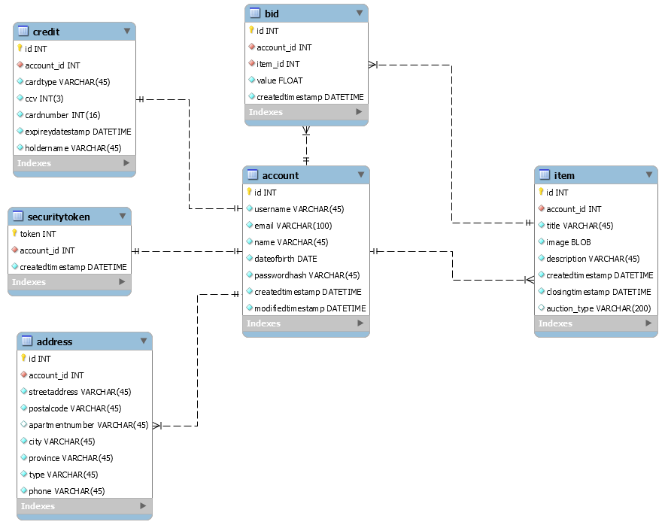

* 1. **Function Aspect**

The functionality of this web application is for users to have an easy and simple way to post and auction items they wish to sell. Features this web application wishes to accomplish include:

* User login/registration: Simple area for users to sign in or register to the website and create a secure session with the website
* Posting auction items: Users have the ability to create auctions and upload information on the item they wish to sell, user’s will also have the ability to choose between the two type of auctions; English and Dutch

i: English auction, a type of auction where bids start from the lowest possible value and increment value with each user’s bid. Highest bid at the specified end date and time wins.

ii: Dutch auction, a type of auction where an item starts at its maximum value and devalues through a specified time interval until it reaches its lowest possible value, the first bid wins

* User bidding on posted items: Users have the ability to bid money on the items they wish to buy
* Dynamic profile pages: Users can view other user’s profile pages containing current auctions and previous auction history
* Email system for notifications: Users will be automatically emailed if items in their auction has been bid on and auctioneers can be emailed by users about the selling item
* Administrative functionality for monitoring user activity: Administrators need to approve users auctions before they become public as well as freeze disruptive accounts
  1. **Network Aspect**

We have decided to make our service only accessible for users living in Canada. This means that we will only have to keep the website in two languages French and English, geographical locations will be broken down into provinces and their respective cities, and we will only have to deal with postal codes in terms of shipping information. All date stamps will be recorded via server time so the issue of time zones will not be interfered with on bidding data. All data will be stored on local databases for development and testing, however they will be moved to separate database servers upon production.

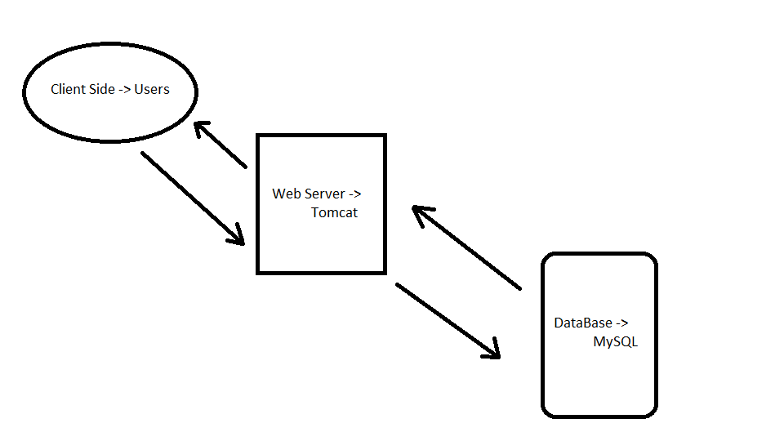

* 1. **People Aspect**

We will have two types of user: default users, and administrators. Default users will have the ability to create/delete their account, bid on auctions, email auctioneers, and create or flag auctions for deletion (deleted auctions must be approved by an administrator). Admins will moderate the auction pages, they have the ability to freeze accounts for review, delete requested auctions created by the auctioneer, and approve auctions to be visible by the public. Admin accounts will be created locally on the database where as users will create their accounts on the website.

* 1. **Timing Aspect**

The biggest time constraint we’ll face is insuring that the bid data users see is as up to date as possible. For handling competing bids we’ll have to simply work in a “first come, first served” system. If a bid is submitted before another be is received second it’ll be treated as though it were submitted second to prevent hackers from tricking the server into thinking a bid was submitted earlier than it was. We’ll also have to handle bids ending, bids will have a timestamp set to determine when they will end, the time remaining will be calculated and displayed by the web browser. For Dutch auctions users will set intervals and amounts the price will drop, the currently acceptable bid will be calculated by the browser and bids will be confirmed as valid when they reach the server. Placing these calculations on the web browser will insure the user has the most up-to-date timing data possible. The server will have to be regularly queried to return the most recent bid data.

* 1. **Motivation Aspect**

Our website will use encrypted password and credit information storing to ensure unwanted breach of information is never given. A security token will also be used to ensure a secure session is always kept for all users.

Privacy is also another issue we have looked at, we have discussed which steps we will be taking to ensure anonymity for every auction. Client’s user names will be hidden on bidding information keeping bidders for auctions anonymous. Emails will remain hidden unless users wish to communicate with auctioneers about current auctions. Contact information will never be publicly displayed and all disputes will be handled through contact with the administration teams.

To ensure the safety of all the users all auctions must be approved before use by the administrative staff of our bidding web application. At any given time an auction can be removed and/or an account can be frozen as well. Always keeping on top safety is our primary concern.

**3 Project Plan**

Version 0.1: Registration / Login Page

We will be creating a webpage that allows user to register or login the website. It will be compulsory for the user to enter all the credentials (name, date of birth, username, password, etc.) while registering and error message (“Required Fields”) will be displayed to the user if any of the fields is left blank.

Version 0.2: Creating Auctions and Uploading image.

The user will login in the website and will be able to create an auction and upload image associated with the auction. The description of the item will be entered by the user and user will enter the starting price for the item.

The auction will be approved before putting live on the website.  
The created auction will have the account id (username) and product id associated with it.

The owner can review the history of the bids placed and the bidder cannot post a bid priced less than the ongoing bid.

Version 0.3: Placing Bids

The user can place the bid on the items he will see on the home screen. There will be a “Bid Now” button on the item, timer on the item will be the time left to close the bid. The user can see the last bid placed and the first and last name of the username that placed the last bid. By clicking the Bid Now button, user can place the bid. The timer will reset if anyone places a new bid on it. When the timer reaches to 0, users will not be able to place the bids on that item.

Version 1: Emailing the winner and owner.

When the bid is closed, the winner and the owner will be sent an automatic email describing the final price. The owner and user will get the details of each other allowing them to contact and discuss the posting of the item etc.

Each team member will have the designated task in the building of the application. The application will be built on several individual tasks. The application has been divided in following sections and the members designated are:

• Registration/login and– Mike Gagnon  
• Creating auctions – Brodie Taillefer  
• CSS – Brodie Taillefer  
• Bidding System – Archit Bhatia  
• Uploading Images – Shawn Pottle  
• Emailing the winner and owner – Archit Bhatia  
• Admin Functions – Richard Fyffe  
• Profile Pages – Shawn Pottle

Each team member will member will spend 40-45 hours outside the school on designated task for the desirable results.